**Jio Mart**

India’s richest man, a billionaire, Mukesh Ambani owns Reliance and its subset organ Jio. Reliance had marked its triumph all across the nation, and even in other foreign nations by its various products, facilities, and applications. Ambani’s Jio has several applications to ease the various accessibilities.

With the Galwan clash, India banned a number of Chinese apps starting the Boycott China movement. With this, started a rage in the Indian citizen to start not to use the Chinese goods and hence show their patriotism. The Indian tech giants including Reliance came up with a wide range of applications that are “Made in India” products. With this fact, the industrialists and market heads are coming up with affordable and similar content. As they learn from the global heads, they tend to copy the concepts of the global rulers of technological advancements, and give names to copying as inspiring!



A few times ago, with the ongoing pandemic, Jio came up with a new application of Jio Mart to ease the market orders and deliveries at the doorsteps making the lockdown easier. Before Jio Mart, Reliance Retail service had already been the top in India by revenue, serving around 3.5 million customers every week.

**Jio Mart and the e-commerce market:**

Jio Mart is a website platform just similar to the other e-commerce shopping giants like Amazon, Flipkart, and BigBasket for online grocery deliveries. Just like the Silicon valley e-commerce platforms, Jio Mart also enables a similar category for the products and the steps to be followed for placing the order. Here are the similarities displayed by Jio Mart to the others:

* To place an order, first, the location is set, then the products are moved to the cart, and finally, the payment mode is selected for confirming the order.
* The payment modes are also similar to the wallet payments to the card payments, and also the cash on delivery option.
* The product category and the subcategories are same too from personal care to fruit, vegetables, dairy, and home care products.

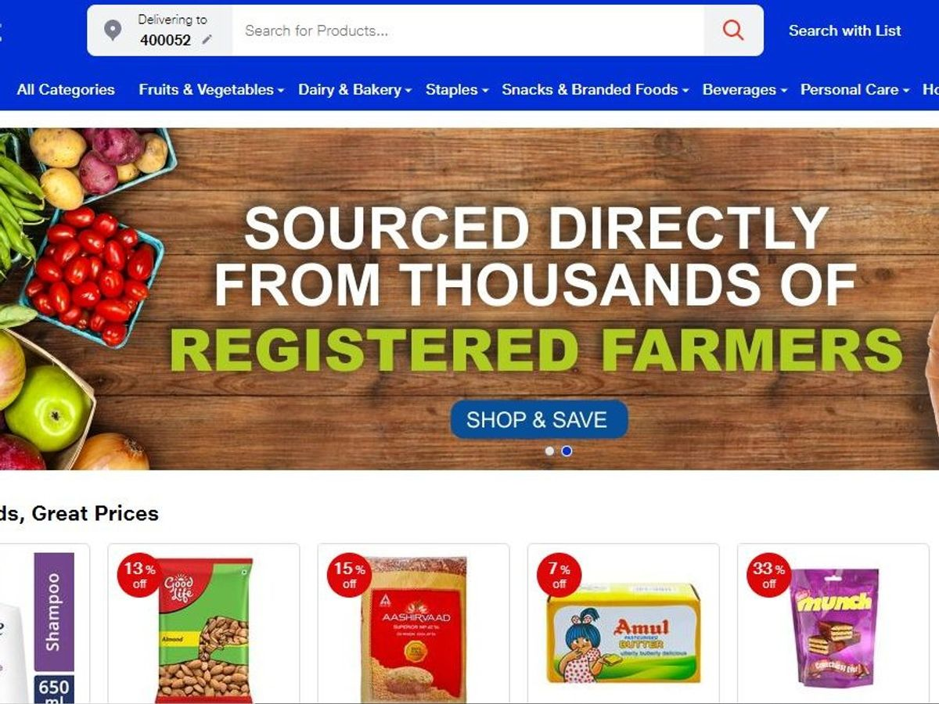

**Ambani’s tactics for success:**

Banning Chinese products might prove out to be a successful trend for Mukesh Ambani and a few Silicon Valley investors. Ambani’s Jio platforms have already raised about 10 billion USD in the last month by selling only about 17% of the stakes. He had managed over 388 million subscribers for Jio that is more than any other telecom operator across the nation.

Just like China, Korea, and Japan, India’s Reliance is also following the same trend of copying the products and providing them at cheap rates to develop their market. Being a billionaire owner of Reliance Jio, Mukesh Ambani is ready to take the losses initially to ensure his monstrous market size in the long run.

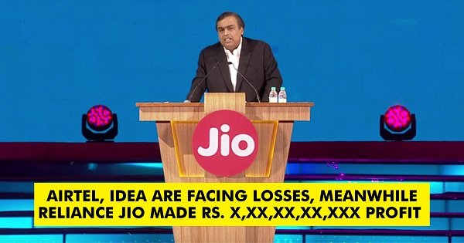

Reliance has been following similar tactics for years to ensure its success pattern and growth rate. Being a billionaire, Mukesh Ambani starts his product’s marketing and release by providing various offers. When a few years back he released Jio SIM, He started it with free distribution and various offers and cheap prices for recharges. With the passing years, by these offers and extra facilities, Jio managed to wipe out the market for various telecom services like Airtel, Vodafone, and Idea. Once he managed to grow his empire, Reliance increased the recharge amounts of Jio and the charges for the other facilities too.

In the case of Jio Mart, Reliance Jio started with providing 50% discounts on various products and many other offers too in hope of developing his market grasp. But, an intelligent individual knows already where it is going to end!

**Conclusion**

A handful of firms have failed in their attempt for successful e-commerce releases in India. Mukesh Ambani, on the other hand, has managed to develop his market size for almost all of his facilities and applications including Jio Mart too.

Necessity is the mother of inventions. But, developing forums have made it the mother of imitation!

Is it that difficult to just come up with some new development? Is innovation not possible to make a large scale development of the nation? Is copying a necessity?

Just like China, maybe Reliance’s success will also develop by being a copycat with cheap prices during the initial times.

